LAB-6 STATIC ROUTE
TOPOLOGY:
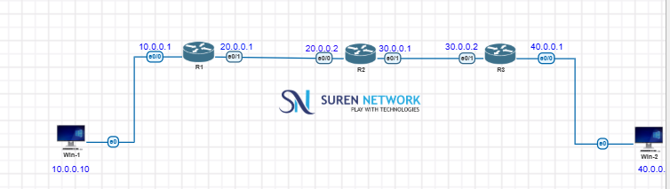

OUTPUT:
